OFFICAL GUIDE TO CARING FOR YOUR CROPPED DOBERMANS EARS
Puppies can be cropped as early as 7 weeks depending on your vet. I personally find it best for the ears to be cropped earlier rather than later so that ears can be posted in the optimum ear growth times. I would say its safe to leave fresh stitched ears unposted unless you want to try a wrap FREE post which allows air to flow through ears. Some vets send puppies home fully posted with bandages, I personally do not agree with this method because it is a breeding ground for bacteria and moisture and guaranteed to get infected. Some newer vets may not be familiar with cropping and may suggest a fully wrap. TIPS: If you plan to use a cone please sure sure to keep it sanitized each day. If the cone is rubbing puppy’s ears it may be bothered by this.
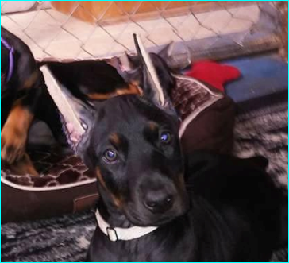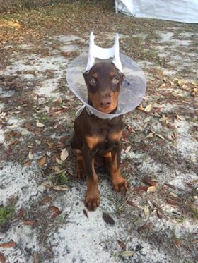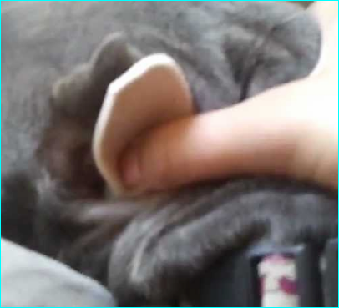
(Puppy on left straight out of surgery has ears posted in a OPEN post method this allows air flow to keep things clean and dry) Supervise small children around puppy and do not allow other animals in the home lick ears, otherwise ears will become infected. Ideally you want a speedy recovery with little scarring. (Puppy on Right has a closed ear posting) Ask your vet before scheduled cropping and request OPEN post or request no posting. The OPEN post method you have to be careful around water because it will absorb. Purchase EXTRA soft mole skins (feet sections, can be found at wal-mart, rite aid had a store brand which is really nice) Cut to shape of the ear and my vet uses Lock tite super glue, or you can use eye lash glue, surgical skin glue etc. Typically lasts for 2-5 days sometimes longer depends how much your puppies ears sweat. Last photo is mole foam.
Properly cleaned ears will result in a speedy recovery and allow everything to heal and be beautiful. So stitches stay in 7-10 day(s)/ watch stitches if they become imbedded into the skin after say 3rd or 5th days (typically swelling after surgery takes time to go down) I tend to pop stitches with tiny scissors a few as needed until the 7-10th day, every puppy heals at a different rate. ONLY pop stitches that are becoming imbedded in skin don’t pop to many until the recommended time. Typically takes 2 people 1 to hold puppy and one with scissors (if you’re not comfortable doing this take puppy back to vet and get vets opinion). Or you can wait the whole time frame and take to vet and have vet remove stitches all at once (I just find its easier on puppy my way).
Scabbing after surgery is NORMAL. If you notice green or yellow discharge like in the picture below that is infection. Don’t freak out! STEP 1: I like to use polyspoirn or neospirn on the puppies ears. Apply with a Q-tip around the scabbing (some have pain relievers and antibiotics those are the best!) You put it on and wait a few mins it will help loosen up all the scabbing so it will wipe away easily. It will be OK! STEP 2: So when you see the infection you want to get some warm water in a saucer (bottled water is best!) dish and put table salt in mix with spoon (LOTS OF SALT) Do not use peroxide it kills the good cells that are trying to heal the area. Use a Q-tip and gently scrub the infected area. You will notice INSTANT IMPROVEMENTS. STEP 3: Give your puppy a treat!
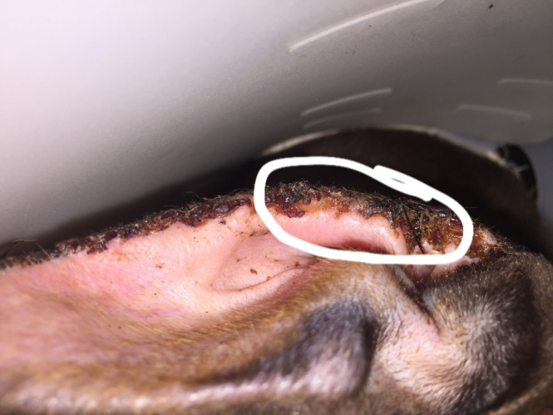
Clean ears should look similar to this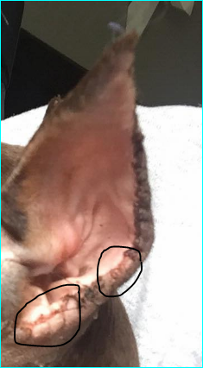 Areas outside of the black circle still need to be cleaned for perfection as you can see there is still scabbing on this puppies ears. This should be repeated daily for best results. If you catch a dog in the house hold licking ears be sure to clean with salt water and re-apply a pea sized amount for the whole ear. To much will result in goopy ears and possible inner ear infection. Do not use this forum as subtitle for vet care. [Courteous of SOUTH PAWS DOBERMAN]

